JKC ANNUAL REPORT - 2021-2022

Name of the College : S.Y.T.R. Govt. Degree College, Madakasira,
District : Sri Satya Sai District

JKC STAFF MEMBERS

S.No. | Name | Designation | Qualification | Cell No.
1 | Dr.R.Subbaiah | Principal & JKC Chairman | M.A., Ph.D | 9704406695
2 | A.Praveen Kumar | JKC Coordinator | M.A., | 7981565361
3 | K.N.Venkatesh | JKC Full Time Mentor | M.B.A  (H.R & FINANCE) | 8179411035

Micro soft Upskilling Programme :
Sri. A.Praveen Kumar, Lecturer in English and JKC Coordinator and Dr.A.Anil Kumar. Lecturer in Botany explains the Importance of Micro soft Upskilling program to students.
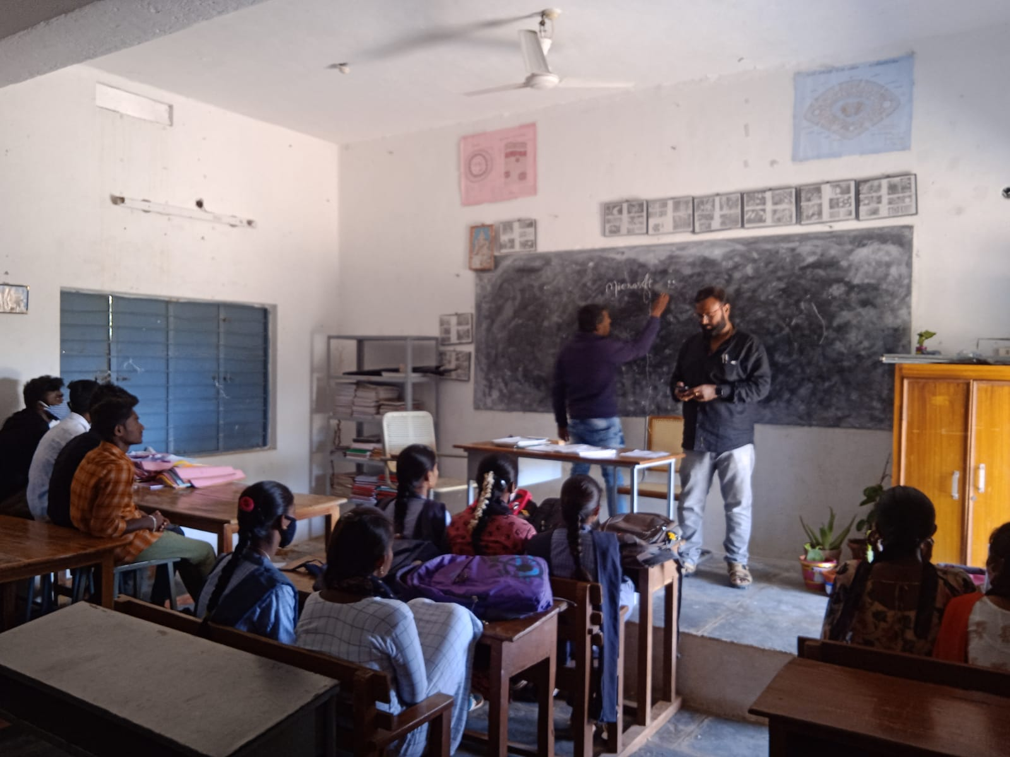
Sri. A.Praveen Kumar, Lecturer in English and JKC Coordinator, Explains Importance, Registration Process of Micro soft Upskilling program to students
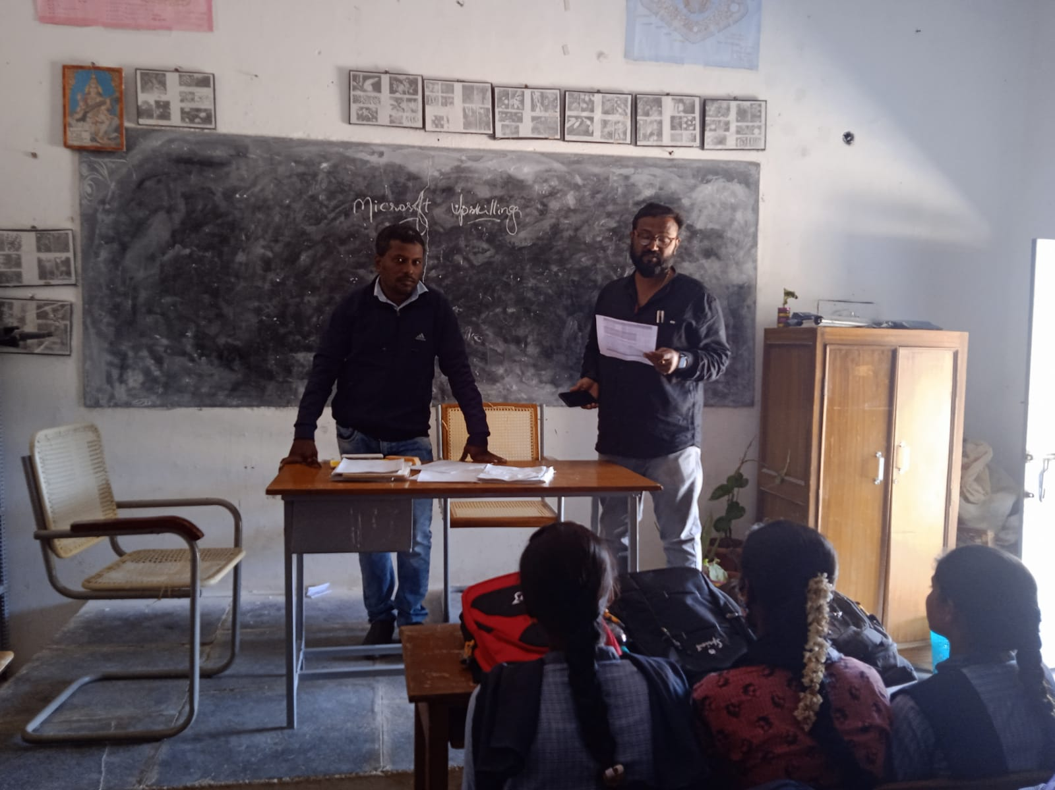
Dr.A.Anil Kumar. Lecturer in Botany explains the Importance of Micro soft Upskilling program to students.

Virtual Conference on Micro Soft Upskilling Program :
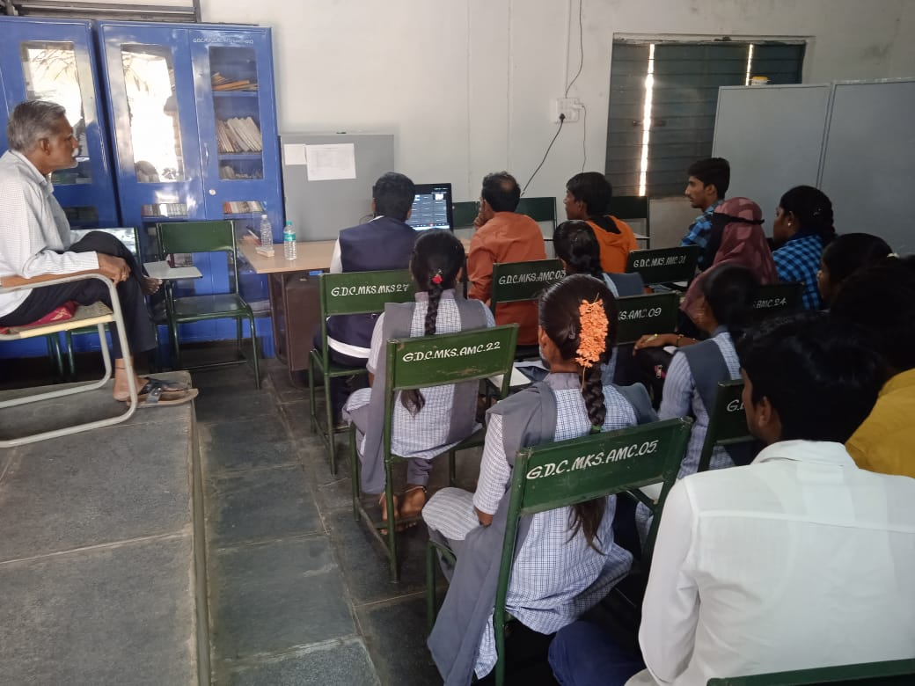
Dr.R.Subbaiah, Principal of the College, attended the Virtual conference along with staff and students in the college
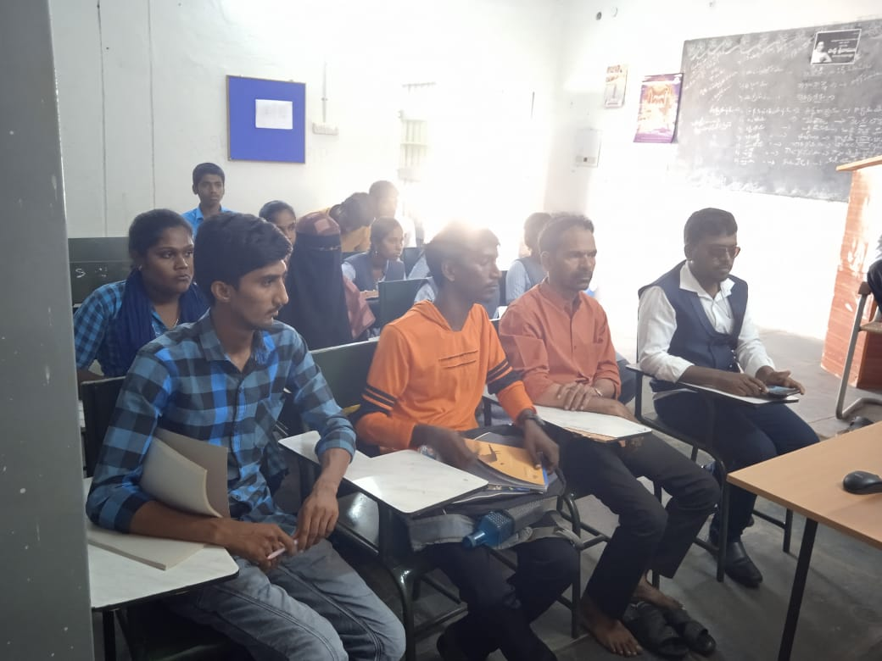
Sri. A.Praveen Kumar, Lecturer in English and JKC coordinator and Dr. V.Jagannath, Lecturer in Economics attended the virtual conference along with students.

TCS - Certificate Distribution :
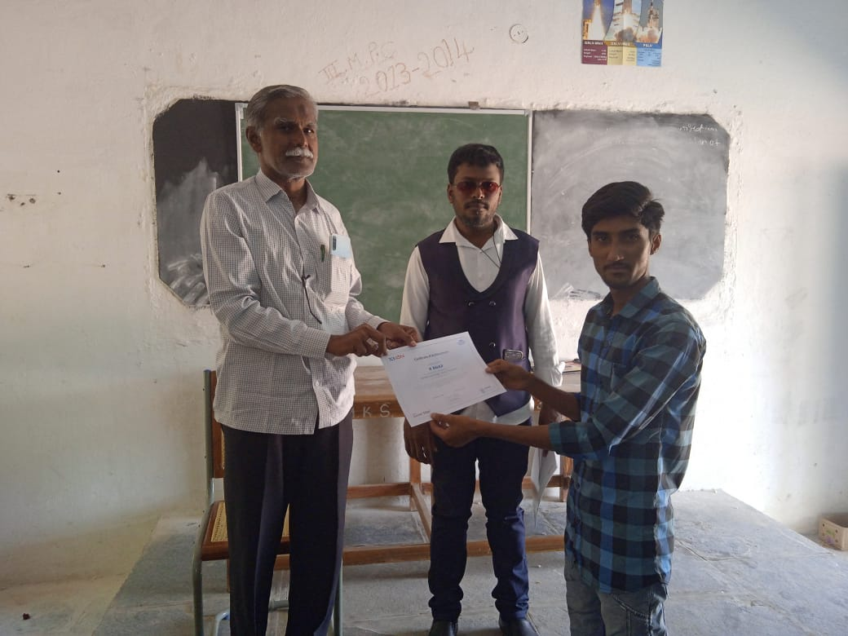

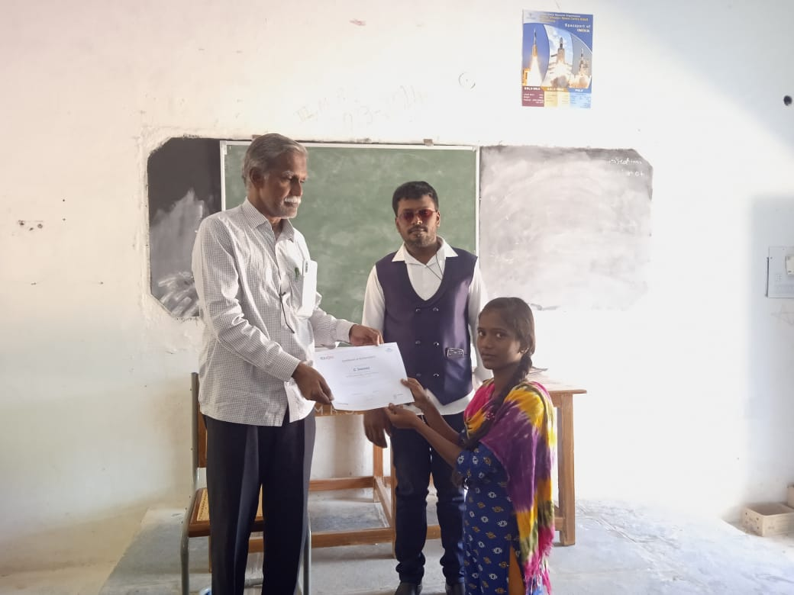
Dr.R.Subbaiah Principal of the College and Sri. A.Praveen Kumar, Lecturer in English and JKC coordinator distribute the TCS certificates to students.

Campus Drive :
S.Y.T.R. Govt. Degree College, Madakasira, Jawahar Knowledge Center organized Campus Drive on 25-01-2022.
Name of the Company: ACT plast paints Pvt. Ltd., Penulonda.

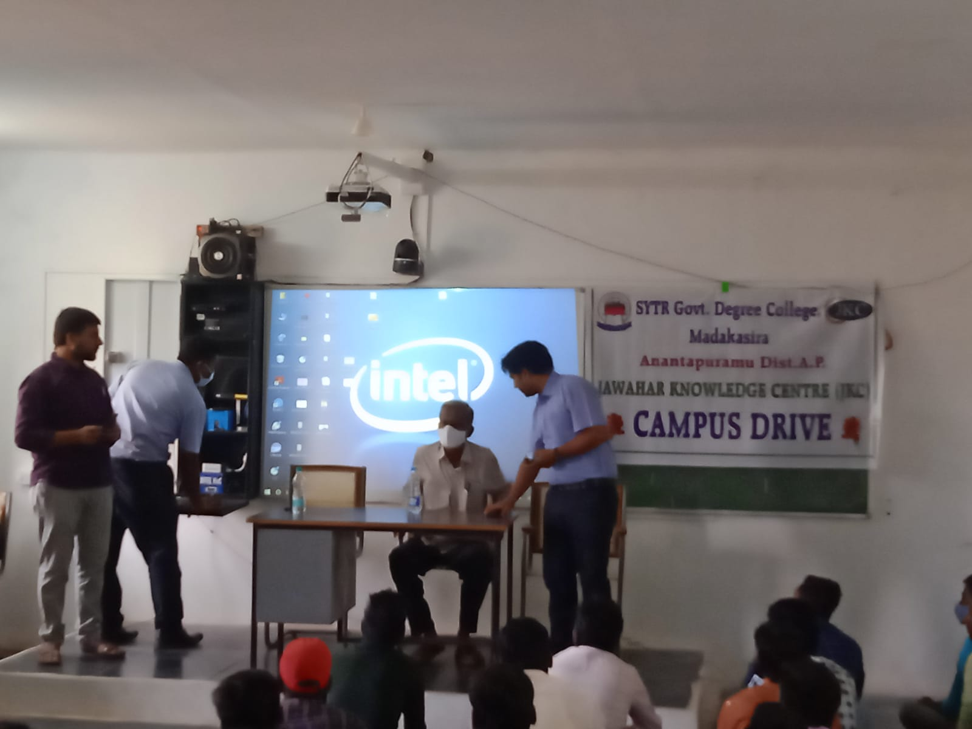
Dr. R.Subbaiah, Principal of the College Inagutaes the Campus Drive
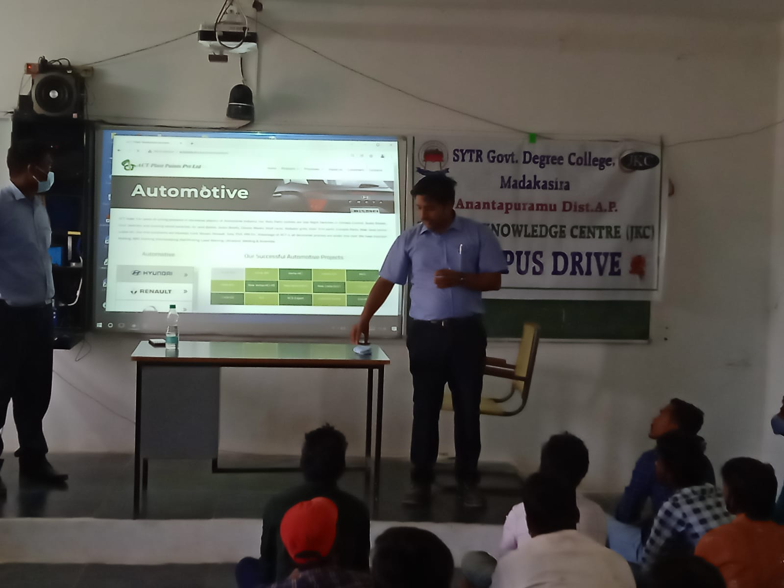
Mr.R.Suresh, HR of ACT plast paints Pvt. Ltd. Penukonda briefing about the Company and Job profile

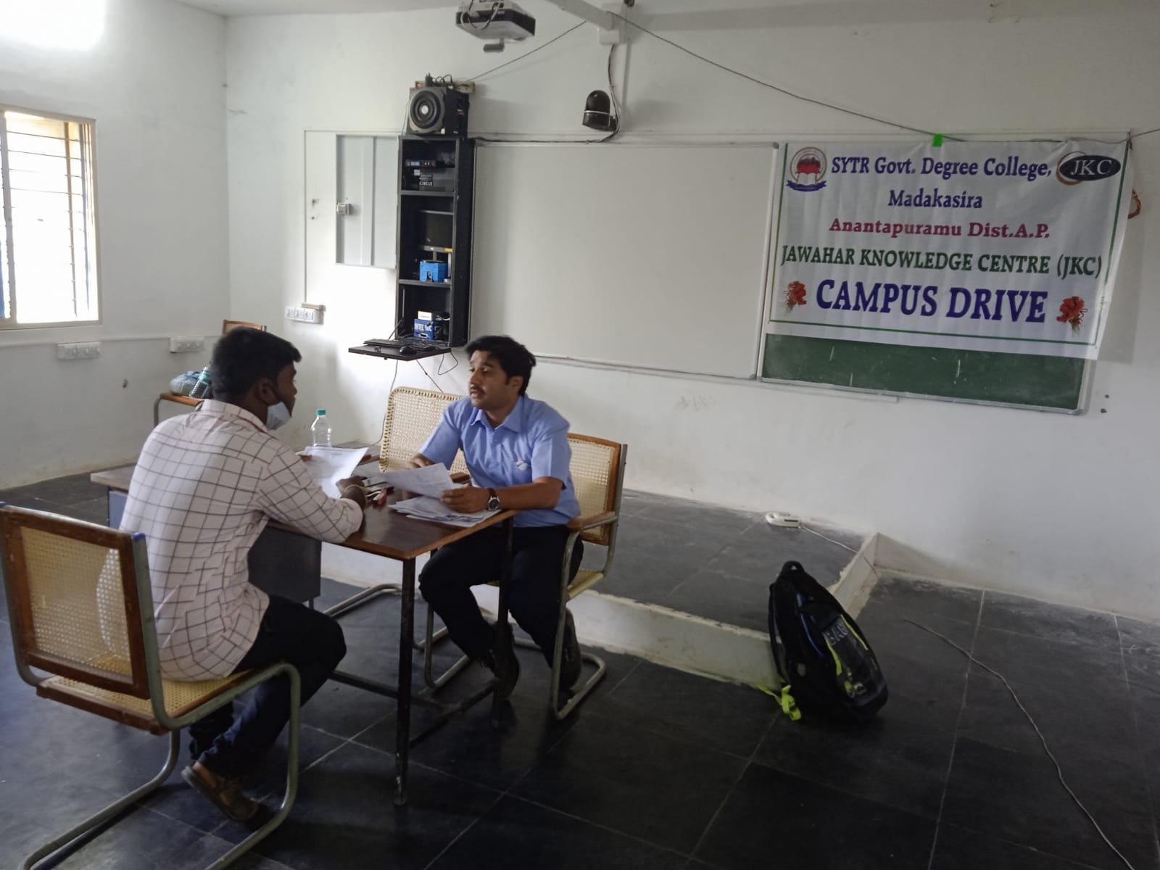

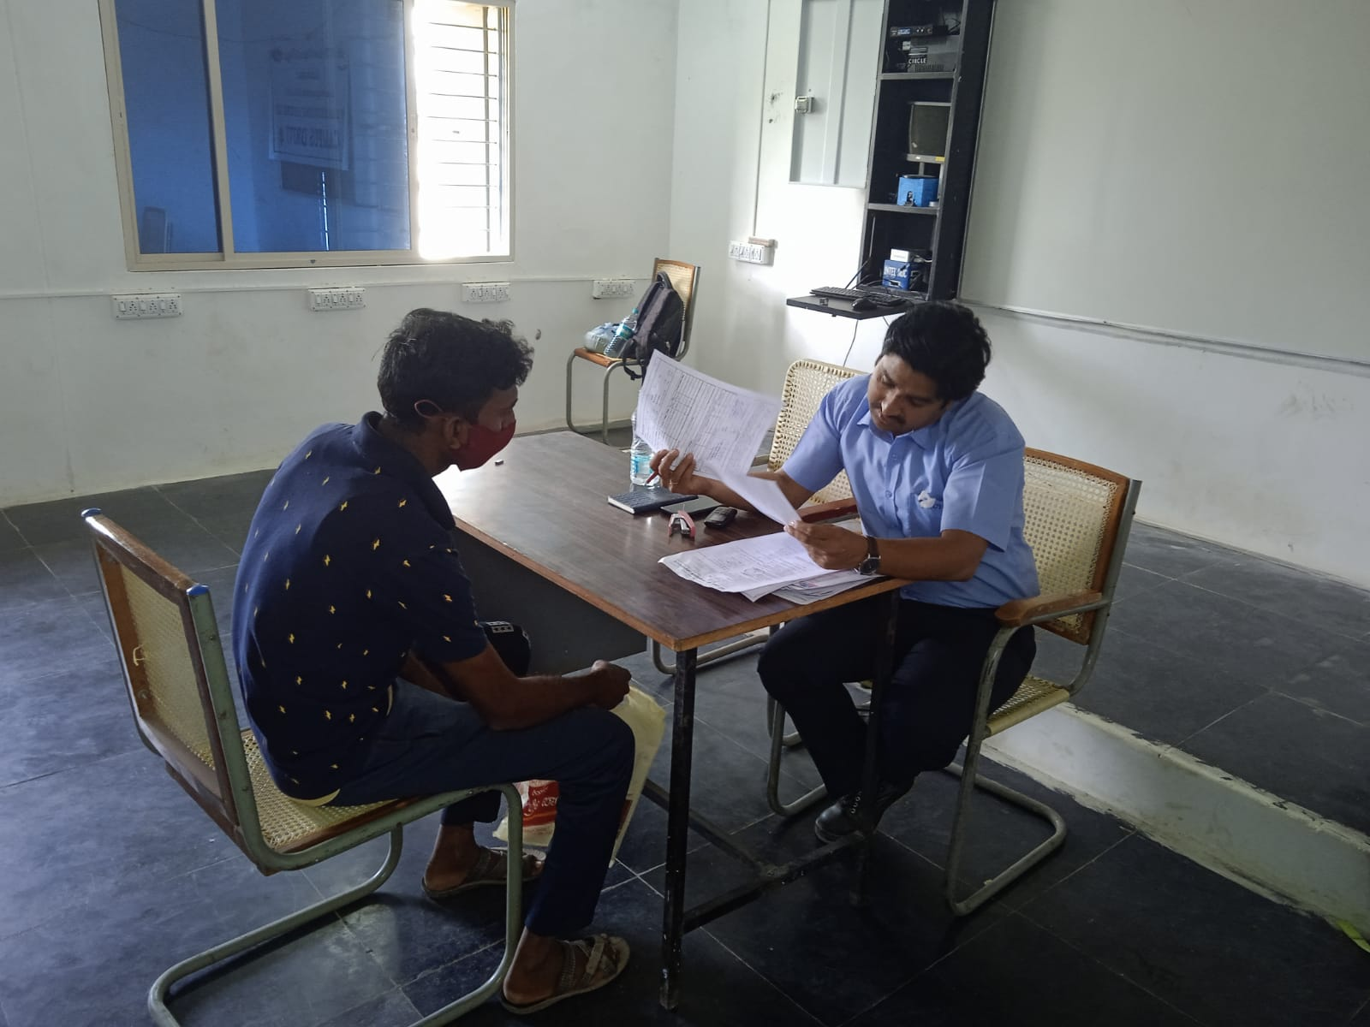
Students attended the Personal Interview by Mr.R.Suresh, HR of ACT plast paints Pvt. Ltd. Penukonda

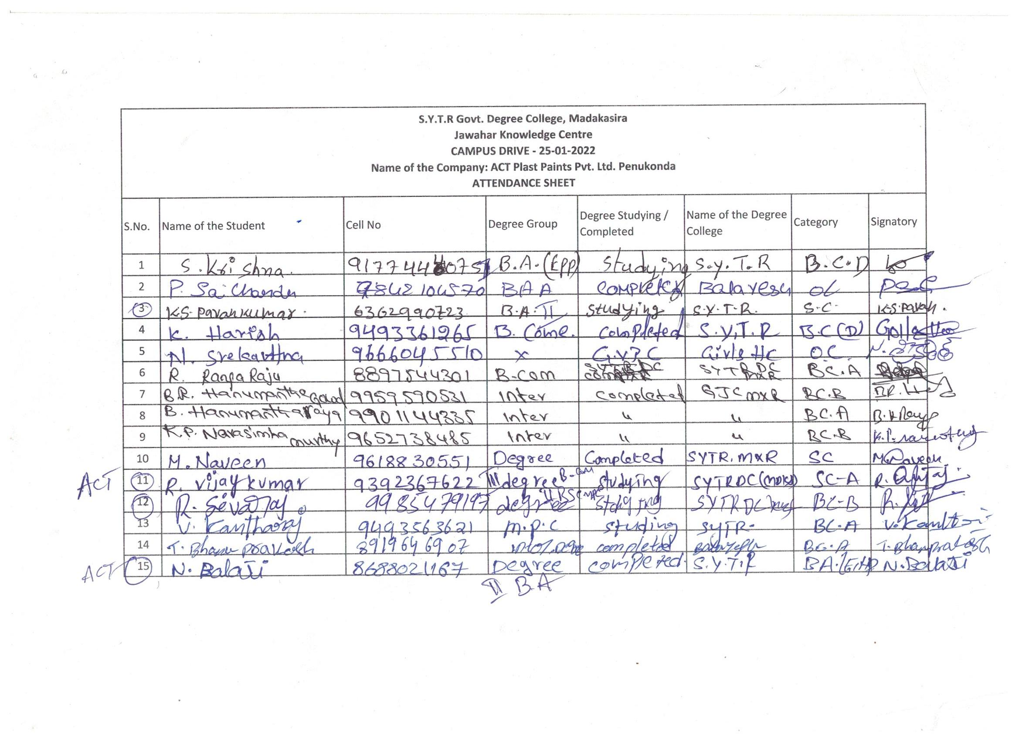
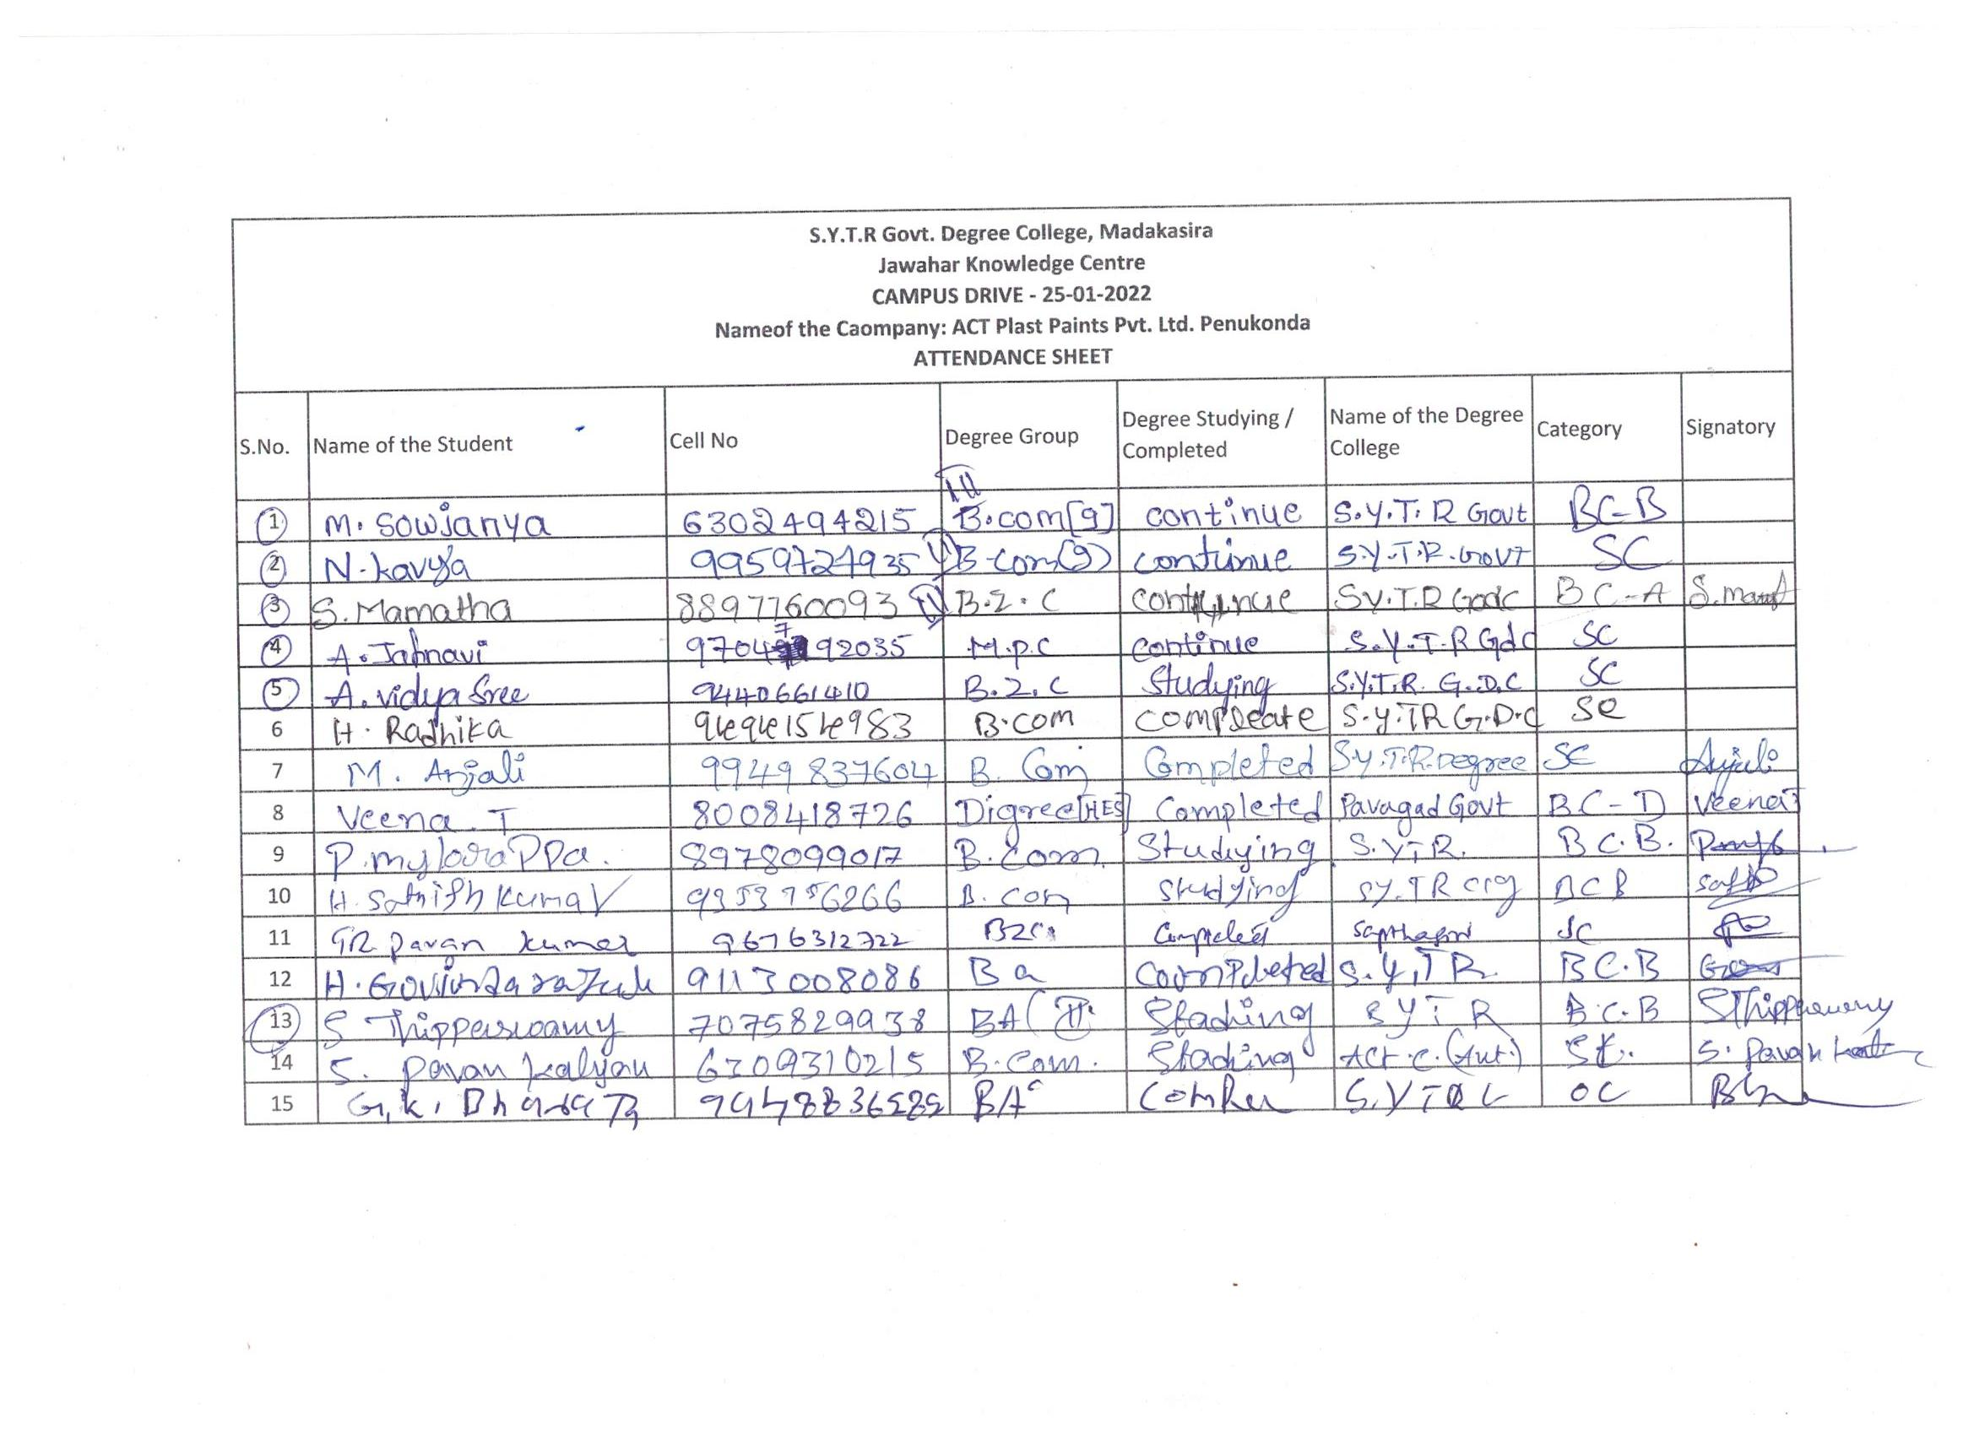
Students Attendance sheets

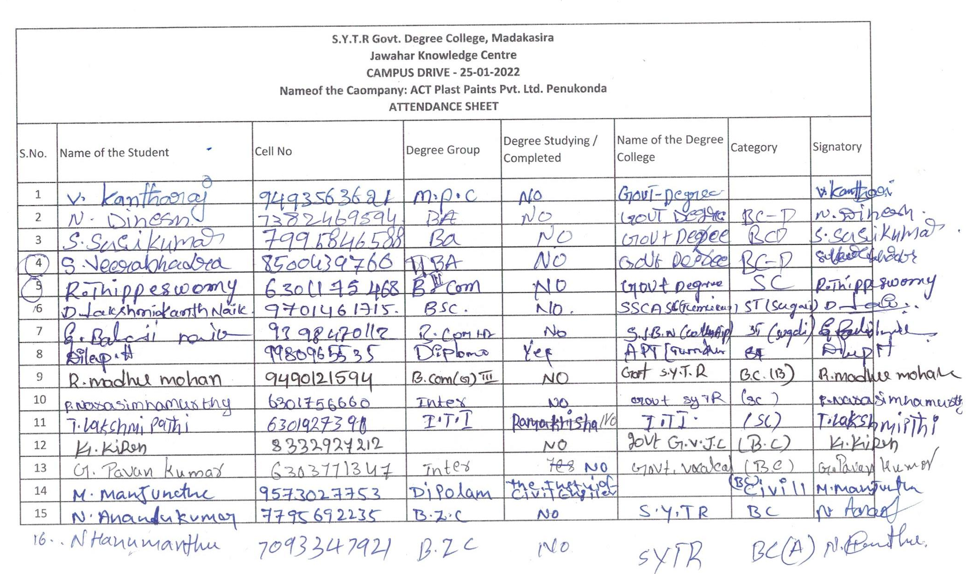

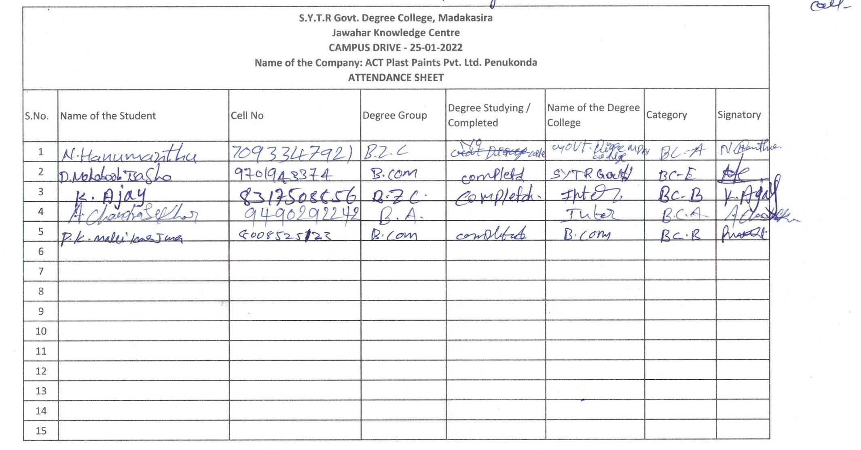
Students attendance sheets

The Following list of Students Selected for ACT Interviews

